### **What is JavaScript**

JavaScript (js) is a light-weight object-oriented programming language which is used by several websites for scripting the webpages. It is an interpreted, full-fledged programming language that enables dynamic interactivity on websites when applied to an HTML document. It was introduced in the year 1995 for adding programs to the webpages in the Netscape Navigator browser. Since then, it has been adopted by all other graphical web browsers. With JavaScript, users can build modern web applications to interact directly without reloading the page every time. The traditional website uses js to provide several forms of interactivity and simplicity.

Although, JavaScript has no connectivity with Java programming language. The name was suggested and provided in the times when Java was gaining popularity in the market. In addition to web browsers, databases such as CouchDB and MongoDB uses JavaScript as their scripting and query language.

### **Features of JavaScript**

There are following features of JavaScript:

1. All popular web browsers support JavaScript as they provide built-in execution environments.
2. JavaScript follows the syntax and structure of the C programming language. Thus, it is a structured programming language.
3. JavaScript is a weakly typed language, where certain types are implicitly cast (depending on the operation).
4. JavaScript is an object-oriented programming language that uses prototypes rather than using classes for inheritance.
5. It is a light-weighted and interpreted language.
6. It is a case-sensitive language.
7. JavaScript is supportable in several operating systems including, Windows, macOS, etc.
8. It provides good control to the users over the web browsers.

### **Application of JavaScript**

JavaScript is used to create interactive websites. It is mainly used for:

1. Client-side validation,
2. Dynamic drop-down menus,
3. Displaying date and time,
4. Displaying pop-up windows and dialog boxes (like an alert dialog box, confirm dialog box and prompt dialog box),
5. Displaying clocks etc.

First Example:

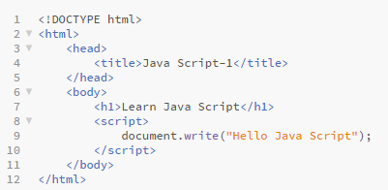

Output:

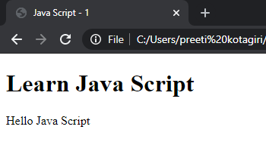

1. JavaScript provides 3 places to put the JavaScript code: within body tag, within head tag and external JavaScript file.
2. The **script** tag specifies that we are using JavaScript.
3. The **text/javascript** is the content type that provides information to the browser about the data.
4. The **document.write()** function is used to display dynamic content through JavaScript.

### **Three Places to put JavaScript code**

1. Between the body tag of html
2. Between the head tag of html
3. In .js file (external javaScript)

#### **Between the body tag of html**

Let’s see a simple example of JavaScript that displays an alert dialog box.’

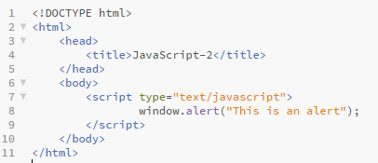

Output:

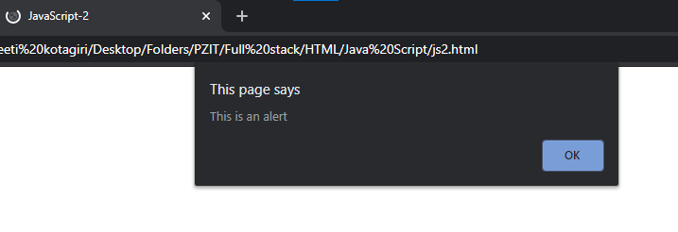

#### **Between the head tag of html**

Here is an example displaying an alert dialog box of JavaScript that is contained inside the head tag.

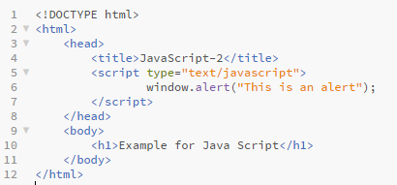

#### 

#### 

#### 

#### **External JavaScript file**

1. We can create an external JavaScript file and embed it in many html pages.
2. It provides code re usability because a single JavaScript file can be used in several html pages.
3. An external JavaScript file must be saved by .js extension. It is recommended to embed all JavaScript files into a single file. It increases the speed of the webpage.

Let's create an external JavaScript file that prints Hello Preeti.

My JavaScript file name is display.js

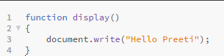

Let's include the JavaScript file into the html page. It calls the JavaScript function on button click.

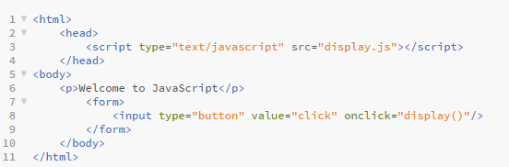

Output:

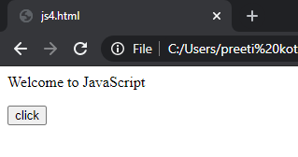

When you click on click button you will find the following

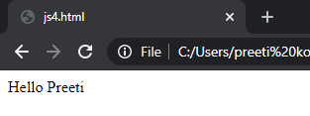

### **Types of JavaScript Comments**

There are two types of comments in JavaScript.

1. Single-line Comment
2. Multi-line Comment

#### **Single line Comment**

It is represented by double forward slashes (//). It can be used before and after the statement.

#### **Multi line Comment**

It can be used to add single as well as multi line comments. So, it is more convenient.

It is represented by forward slash with asterisk then asterisk with forward slash.

Example:

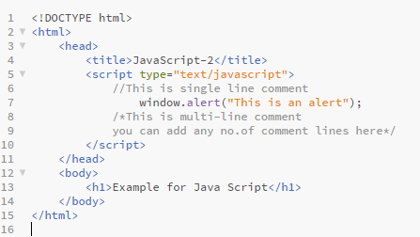

### **JavaScript Variables**

A JavaScript variable is simply a name of storage location. There are two types of variables in JavaScript.

1. Local variable : A JavaScript local variable is declared inside a block or function. It is accessible within the function or block only.
2. Global variable:A JavaScript global variable is accessible from any function. A variable i.e. declared outside the function or declared with a window object is known as global variable.

Example:

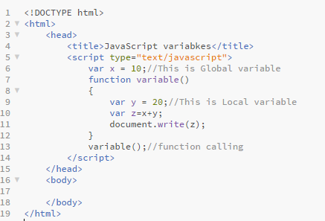

### **JavaScript Browser Objects**

The Browser Object Model (BOM) is used to interact with the browser.

The default object of the browser is window means you can call all the functions of window by specifying window or directly.

1. Window
2. Navigator

### **Window Object**

1. The window object represents a window in the browser. An object of the window is created automatically by the browser.
2. Window is the object of the browser, it is not the object of javascript.
3. The window object is supported by all browsers. It represents the browser's window.
4. All global JavaScript objects, functions, and variables automatically become members of the window object.
5. Global variables are properties of the window object.
6. Global functions are methods of the window object.
7. Even the document object (of the HTML DOM) is a property of the window object:

**window.document.getElementById("header");** is the same as:

**document.getElementById("header");**

#### **Window Size**

Two properties can be used to determine the size of the browser window.

Both properties return the sizes in pixels:

* window.innerHeight - the inner height of the browser window (in pixels)
* window.innerWidth - the inner width of the browser window (in pixels)

#### **Window Methods**

The important methods of window object are as follows:

|  |  |
| --- | --- |
| **Method** | **Description** |
| alert() | displays the alert box containing a message with the ok button. |
| confirm() | displays the confirm dialog box containing a message with ok and cancel buttons. |
| prompt() | displays a dialog box to get input from the user. |
| open() | opens the new window. |
| close() | closes the current window. |
| setTimeout() | performs action after specified time like calling function, evaluating expressions etc. |

### **Navigator Object**

The **JavaScript navigator object** is used for browser detection. It can be used to get browser information such as appName, appCodeName, userAgent etc.

The navigator object is the window property, so it can be accessed by:

Window.navigator or navigator

#### **Properties of navigator object**

There are many properties of navigator objects that return information of the browser.

|  |  |  |
| --- | --- | --- |
| No. | Property | Description |
| 1 | appName | returns the name |
| 2 | appVersion | returns the version |
| 3 | appCodeName | returns the code name |
| 4 | cookieEnabled | returns true if cookie is enabled otherwise false |
| 5 | userAgent | returns the user agent |
| 6 | language | returns the language. It is supported in Netscape and Firefox only. |
| 7 | userLanguage | returns the user language. It is supported in IE only. |
| 8 | plugins | returns the plugins. It is supported in Netscape and Firefox only. |
| 9 | systemLanguage | returns the system language. It is supported in IE only. |
| 10 | mimeTypes[] | returns the array of mime type. It is supported in Netscape and Firefox only. |
| 11 | platform | returns the platform e.g. Win32. |
| 12 | online | returns true if the browser is online otherwise false. |

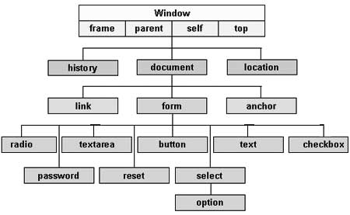

### **Document Object Model(DOM)**

The DOM is the Document Object Model, which deals with the document, the HTML elements themselves, e.g. document and all traversal you would do in it, events, etc.

A Document object represents the HTML document that is displayed in that window. The Document object has various properties that refer to other objects which allow access to and modification of document content.

The way a document content is accessed and modified is called the Document Object Model, or DOM. The Objects are organized in a hierarchy. This hierarchical structure applies to the organization of objects in a Web document.

### **Document Object**

Document object − Each HTML document that gets loaded into a window becomes a document object. The document contains the contents of the page.

#### **Properties of DOM**

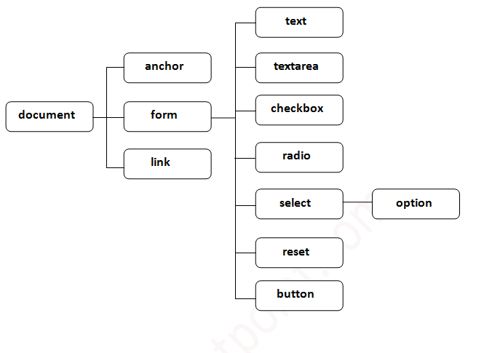

1. Window Object: Window Object is always at the top of the hierarchy.
2. Document object: When an HTML document is loaded into a window, it becomes a document object.
3. Form Object: It is represented by form tags.
4. Link Objects: It is represented by link tags.
5. Anchor Objects: It is represented by a href tag.
6. Form Control Elements : Form can have many control elements such as text fields, buttons, radio buttons, and checkboxes, etc.

#### **Methods of Document Object:**

1. write(“string”): writes the given string on the document.
2. writeln(“string”) : writes the given string on the document with newline character at the end.
3. getElementById(): returns the element having the given id value.
4. getElementsByName(): returns all the elements having the given name value.
5. getElementsByTagName(): returns all the elements having the given tag name.
6. getElementsByClassName(): returns all the elements having the given class name.